- Using a variable on your calculator, compute 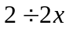 given that 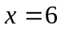.
- Without using a variable on your calculator, compute 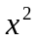 given that 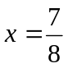.
- What is 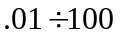in standard form?
- Using a variable on your calculator, compute 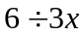 given that .
- Without using a variable on your calculator, compute given that 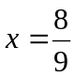.
- What is the sine of .5 degrees rounded to the nearest ten thousandth?
- Using a variable on your calculator, compute 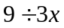 given that 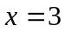.
- Without using a variable on your calculator, compute given that 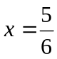.
- What is 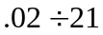 rounded to 3 significant figures?
- Using a variable on your calculator, compute 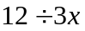 given that 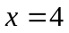.
- Without using a variable on your calculator, compute given that 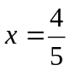.
- What is 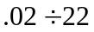 rounded to two significant figures?
- Using a variable on your calculator, compute 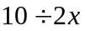 given that 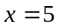.
- Without using a variable on your calculator, compute given that 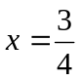.
- What is 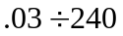 rounded to the nearest hundred thousandth?

